Course Five

The Nuts and Bolts of Machine Learning


Instructions
Use this PACE strategy document to record decisions and reflections as you work through the end-of-course project. As a reminder, this document is a resource that you can reference in the future and a guide to help consider responses and reflections posed at various points throughout projects.

Course Project Recap
Regardless of which track you have chosen to complete, your goals for this project are:
- Complete the questions in the Course 5 PACE strategy document
- Answer the questions in the Jupyter notebook project file
- Build a machine learning model
- Create an executive summary for team members and other stakeholders

Relevant Interview Questions
Completing the end-of-course project will empower you to respond to the following interview topics:
- What kinds of business problems would be best addressed by supervised learning models?
- What requirements are needed to create effective supervised learning models?
- What does machine learning mean to you?
- How would you explain what machine learning algorithms do to a teammate who is new to the concept?
- How does gradient boosting work?

Reference Guide:
This project has seven tasks; the visual below identifies how the stages of PACE are incorporated across those tasks.
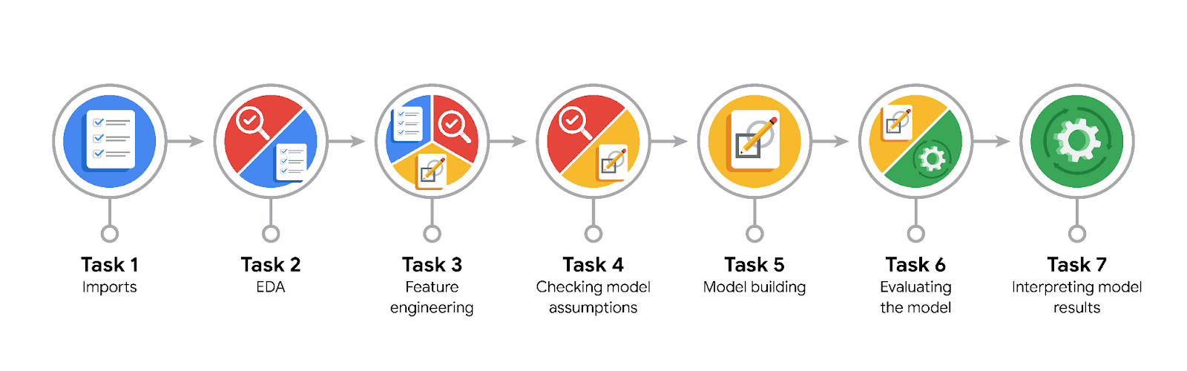

Data Project Questions & Considerations
PACE: Plan Stage
- What are you trying to solve or accomplish?
The goal of this project is to build a machine learning model that predicts whether a customer will leave a tip or not.

- Who are your external stakeholders that I will be presenting for this project?
The external stakeholders are the New York City Taxi & Limousine Commission (New York City TLC).

- What resources do you find yourself using as you complete this stage?
The project description.

- Do you have any ethical considerations at this stage?
The main ethical consideration concerns the objective of the project itself, which aims to maximize the tips that taxi drivers get. This further promotes the tipping culture, which is not beneficial for the taxi drivers nor the customers.

- Is my data reliable?
Whether the data is reliable or not needs to be determined based on the data available. If there is a large amount of data available that covers all possible trip variations, and if there are few missing values and outliers, then it is likely reliable.

- What data do I need/would like to see in a perfect world to answer this question?
We would need to know the true values of the recorded trips.

- What data do I have/can I get?
The data provided by the NYC TLC.

- What metric should I use to evaluate success of my business/organizational objective? Why?
The usual metrics used for evaluating classification models: accuracy, precision, recall, F1 score, AUC score.

PACE: Analyze Stage
- Revisit “What am I trying to solve?” Does it still work? Does the plan need revising?
Yes, it still works, as the data available can be used for solving the problem.

- Does the data break the assumptions of the model? Is that ok, or unacceptable?
The assumptions of the model were not investigated in detail. But the dataset is considered sufficiently large (more than 10 thousand records), and the records are assumed to be independent from each other.

- Why did you select the X variables you did?
Only the variables that are assumed to have some predictive power with respect to the target variable were kept. Also, variables used for extracting new variables were dropped.

- What are some purposes of EDA before constructing a model?
EDA helps identify potential issues with the data (missing values, outliers) which might affect the performance of the model. EDA also helps understand the types of variables contained in the data, which is needed to determine what kind of model can be built. EDA also help with identifying relationships between variables.

- What has the EDA told you?
The EDA steps performed in the notebook helped identify the columns needed to extract the target variable. The analysis carried out also helped identify variables that are unlikely to be useful for predicting the target variable, thereby supporting the feature selection step.

- What resources do you find yourself using as you complete this stage?
The functions provided by the Pandas package are helpful for performing EDA.

PACE: Construct Stage
- Do I notice anything odd? Is it a problem? Can it be fixed? If so, how?
The tip amount was identified as being 0 for payments made in cash. Therefore, only records for trips paid by credit card were retained.

The calculation of the target variable resulted in a few NaN values, due to the total fare amount being 0 in some cases. The corresponding records had to be removed.

- Which independent variables did you choose for the model, and why?
The variables derived from the tpep_pickup_datetime, as well as the mean duration and mean distance variables created in the previous step of the project were kept. The variables used for deriving these variables, as well as those used for deriving the target variable, were dropped. The 'RatecodeID', 'PULocationID', and 'DOLocationID' were also chosen as they may have some predictive power.

- How well does your model fit the data? What is my model’s validation score?
Based on the test data, the following scores were obtained for the two models that were trained:
model precision recall F1 accuracy ROC AUC
Random Forest Classifier 0.682267 0.816428 0.743343 0.703243 0.696942
XGBoost 0.681347 0.818295 0.743568 0.702915 0.696492

- Can you improve it? Is there anything you would change about the model?
There are likely ways to improve both models by further tuning their hyperparameters, and by adding or transforming features.

- What resources do you find yourself using as you complete this stage?
By iterating over different sets of hyperparameter values, and analysing the resulting metric scores, it is possible to identify the best-fitting hyperparameter values.

PACE: Execute Stage
- What key insights emerged from your model(s)? Can you explain my model?
The XGBoost model was looked at in more detail: the best model that was obtained uses only 3 features. It is not possible to understand how come those features have the highest predictive power.

- What are the criteria for model selection?
The scores of various metrics are the primary way of selecting a model. Other criteria include how understandable the model is, its complexity, its resilience against changes in input data, and its computational requirements.

- Does my model make sense? Are my final results acceptable?
The XGBoost model does not make much sense, as the features selected for the final model trained are not intuitive. However, this does not prevent the model from being used for prediction purposes.

- Do you think your model could be improved? Why or why not? How?
Yes. More hyperparameter values could be tested, which could lead to a better performing model. But likely the best improvement would be to collect data for new features that describe the behavior of customers, in particular their tipping history.

- Were there any features that were not important at all? What if you take them out?
Based on the XGBoost model, most features were apparently not needed, or redundant. This means that if there were dropped before training the model, the exact same performance would be obtained.

- What business/organizational recommendations do you propose based on the models built?
If the client really wants to proceed with implementing an app that tells drivers whether a customer is likely to give a generous tip, they could use the model developed. It would be however highly recommended to provide a clear explanation to drivers to inform them that the predictions are highly uncertain, and that often a customer that is indicated as being a generous tipper turns out not to be.

- Given what you know about the data and the models you were using, what other questions could you address for the team?
Are there other target variables we could try to predict that would help taxi drivers?

- What resources do you find yourself using as you complete this stage?
This stage requires computing the performance metrics of the models trained and assessing whether the performance is good enough to fulfil the intended purpose of the model. The functions contained in the scikit-learn library enable to quickly and easily assess the performance of the models trained.

- Is my model ethical?
No, not really. Even though the model is limited to predicting just whether a customer is a generous tipper or not, I consider this still unethical, as the model promotes the tipping culture. The fare amounts should be such that tips are not needed for the drivers to have wage that is sufficient for living.

- When my model makes a mistake, what is happening? How does that translate to my use case?
This is likely pointing to an issue with the hyperparameter values chosen, or the features that were selected to train the model, or that there is an insufficient number of observations for training the model. It can often happen that the data is simply not suitable for training a model to predict the desired target variable.

